# Department of Electrical and Electronic Engineering (EEE) Faculty of Engineering (FE)

**American International University- Bangladesh (AIUB)**

Laboratory Report

Electronic Devices Laboratory

Semester: Spring 2021-22

Date of Report Submission:17-04-2022

Date of Experiment: 13-03-2022

Experiment No: 06

Experiment Title: Study of BJT Biasing Circuit

|  |  |  |  |
| --- | --- | --- | --- |
| **Group No.** | **Group Members** | | |
|  | ID | Name |
| 3 | 1. | **20-42195-1** | **LEO, NAFINUR** |
| 2. | **20-42752-1** | **HOWLADER, MD. SHAKIB** |
| 3. | **20-42794-1** | **FAHIM, SHAH NAWAJ** |
| 4. | **20-42853-1** | **RAHMAN, HASIBUR** |
| 5. | **20-42870-1** | **HASSAN, MD. ALIF** |
|  |  |  |

**Marking Rubrics for Laboratory Report (to be filled by Faculty)**

|  |  |  |  |  |
| --- | --- | --- | --- | --- |
| **Objectives** | **Unsatisfactory (1)** | **Good (2-3)** | **Excellent (4-5)** | **Marks** |
| **Theory** | The relevant theories are not being described properly. | Part of the relevant theories are described with proper  mathematical expression and circuit diagrams (if any) | All the relevant theories are included with proper descriptions,  mathematical expressions and circuit diagrams. (if any) |  |
| **Simulation circuits & Results** | Simulation circuits are not included in this report. | Partial simulation circuit results are included in this report. | All the simulation circuits are included in this report with  appropriate results. |  |
| **Discussion, Comparison between theoretical and simulation results** | Cannot reach meaningful conclusions from experimental data; Cannot  summarize or compare findings to expected results | Can extract most of the accurate data. Answers to the report questions are partially correct;  Summarize finding in an incomplete way | Can extract all relevant conclusion with appropriate answer to the report questions; Summarize  finding in a complete & specific way |  |
| **Organization of the report** | Report is not prepared as per the instruction. | Report is organized despite of few missing sections as per the recommended structure. | Report is very well organized. |  |
| **Comments** | Assessed by (Name, Sign, and Date) | | Total (out of 20): |  |

**Abstract:**

The operating point (Q) of BJT is very important for amplifiers, since a wrong ‘Q’ point selection increases amplifier distortion. It is imperative to have a stable ‘Q’ point, meaning that the operating point should not be sensitive to variation to temperature or BJT ***β***, which can vary widely. In this experiment, four different circuits will be analyzed for two different ***β*** to check the stability of biasing points.

The analysis of the BJT circuits is a systematic process. Initially, the operating point of a transistor circuit is determined then the small signal BJT model parameters are calculated. Finally, the dc sources are eliminated, the BJT is replaced with an equivalent circuit model and the resulting circuit is analyzed to determine the voltage amplification (AV), current amplification (Ai), Input impedance (Zi), Output Impedance (Zo), and the phase relation between the input voltage (Vi) and the output voltage (Vo).

The experiment is a very good practical realization of bipolar junction transistor (BJT) biasing circuit.A BJT biasing circuit will be designed and simulated to find DC operation point using a circuit simulation tool. Then a fixed-biasing and a self-biasing BJT circuits will be implemented on the trainer board to find DC operation point for two different β of the transistor.

**Objective:**

The main objectives of this experiment are to- 1. Establish the proper operating point

2. Study the stability of the operating point with respect to changing ***β*** in different biasing circuits

**Theory and Methodology:**

The dc analysis is done to determine the mode of operation of the BJT and to determine the voltages at all nodes and currents in all branches. The operating point of a transistor circuit can be determined by mathematical or graphical (using transistor characteristic curves) means. Here we will describe only the mathematical solution.

Q

R

C

V

cc

R

B

1

I

c

I

B

I

E

R

B

12

R

C

Q

R

C

V

cc

R

TH

I

c

I

B

I

E

R

C

V

TH

Fig 1: Biasing Circuit

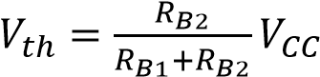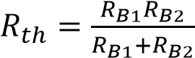We will use the most commonly applied biasing circuit to operate the BJT as an amplifier. A single power supply is used and the voltage divider network consisting of RB1 and RB2 is used to adjust the base voltage. Using the Thevenin equivalent, the voltage divider network is replaced by Vth and Rth where,

and

The dc analysis of the circuit is simple by applying two KVL's at the input and the output loop.

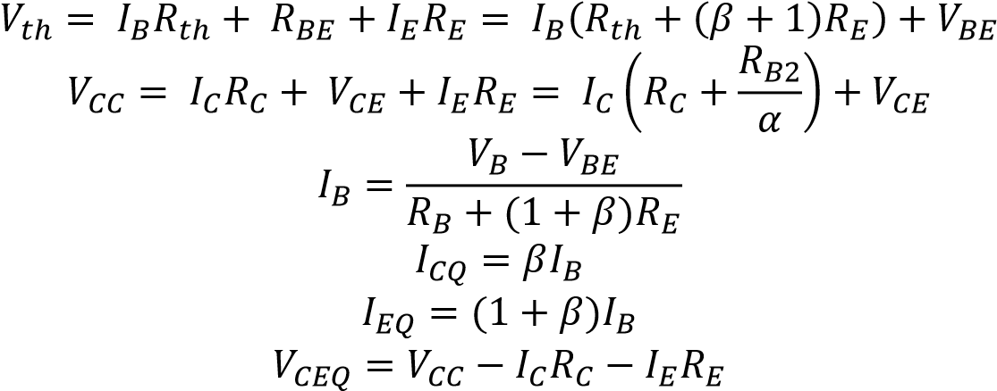

If the BJT is in the active mode the following typical values can be observed:

𝑉𝐵𝐸 ≈ 0.7 𝑉and 𝐼𝐶 ≈ 𝛽𝐼𝐵

RC is used to adjust the collector voltage. Finally, RE is used to stabilize the dc biasing point (operating point). Using the above equations, the stability of biasing points for different transistor of β can be calculated.

**Note:** It is a good idea to set the bias for a single stage amplifier to half the supply voltage, as this allows maximum output voltage swing in both directions of an output waveform. For maximum symmetrical swing, it is clear from the figures that VCE should be VCE= VCC/2.

**Apparatus:**

* 1. Trainer Board
  2. Transistor : C828(NPN), BD135(NPN)
  3. Resistors : R=22KΩ, RC= 470Ω, RB1 = 10KΩ, RE = 560Ω,

RB=500K(Potentiometer)

* 1. DC Power Supply (VCC = +15V DC)
  2. Multimeter
  3. Power Supply Cable

**Precautions:**

Transistors are sensitive to be damaged by electrical overloads, heat, humidity, and radiation. Damage of this nature often occurs by applying the incorrect polarity voltage to the collector circuit or excessive voltage to the input circuit. One of the most frequent causes of damage to a transistor is the electrostatic discharge from the human body when the device is handled. The applied voltage, current should not exceed the maximum rating of the given transistor.

**Experimental Procedure:**

1.Measure the value of Rc by using multimeter and record.

2.Measure the value of β for each transistor by using multimeter.

3.Construct the fixed bias circuit with transistors as shown in fig. 1(a).

4.Set VCC = 15 V and adjust 500K potentiometer until VCE is approximately equal toVCC/2.

5.Measure VCE, VBE and VRC then calculate IC from VRC and RC. IB also calculates from Ic.

6.Now replace the first transistor by second one (Different β) and repeat the step 5.

7.Construct the fixed bias circuit shown in fig. 1 (b) and repeat step 4, 5, 6.

8.Construct the self-bias circuit shown in fig. 2 (a) and repeat step 4, 5, 6.

9.Construct the self-bias circuit shown in fig. 2 (b) and repeat step 4, 5, 6.

10.

**Circuit Diagrams:**

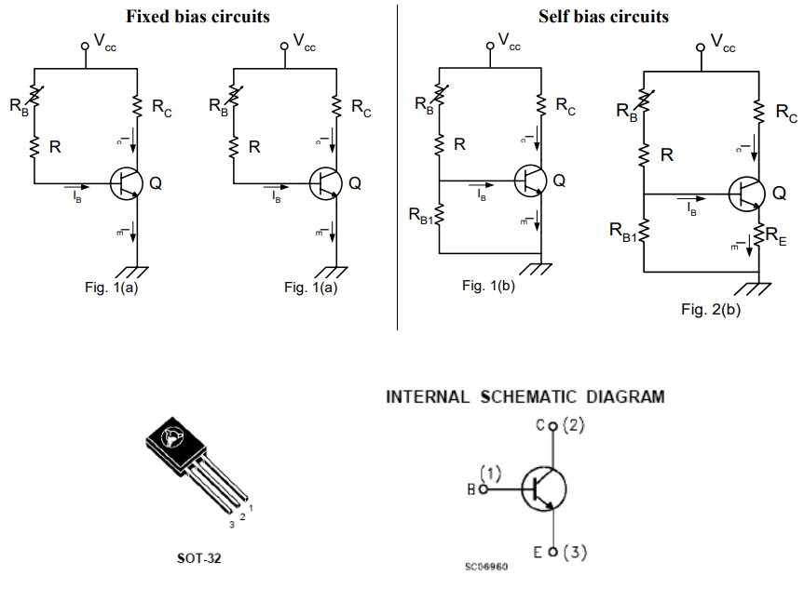

**Simulation and Measurement:**

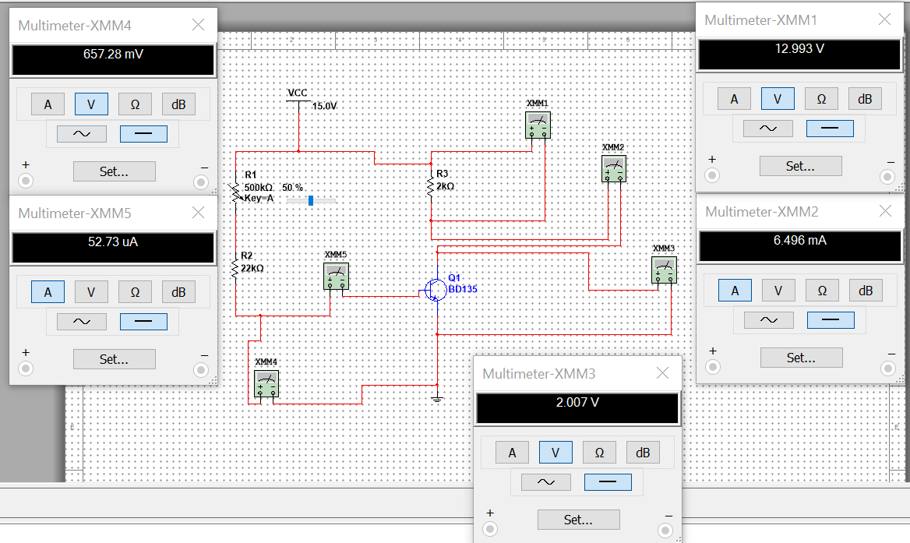

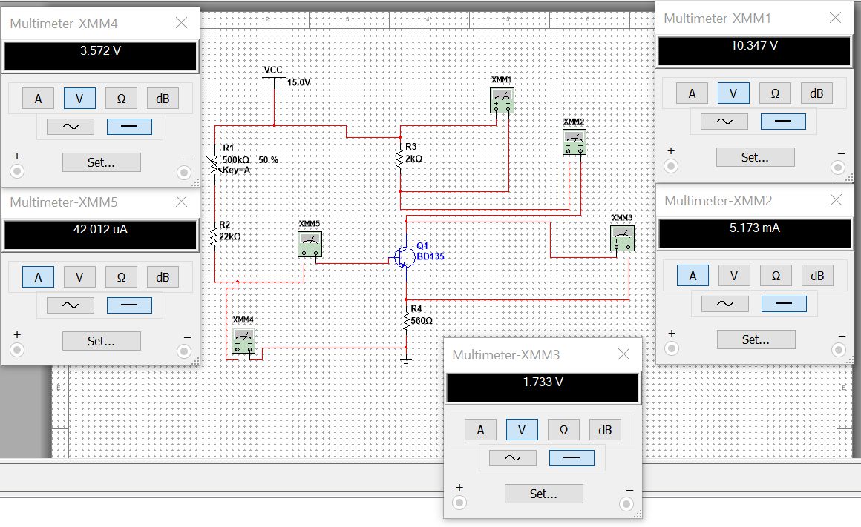

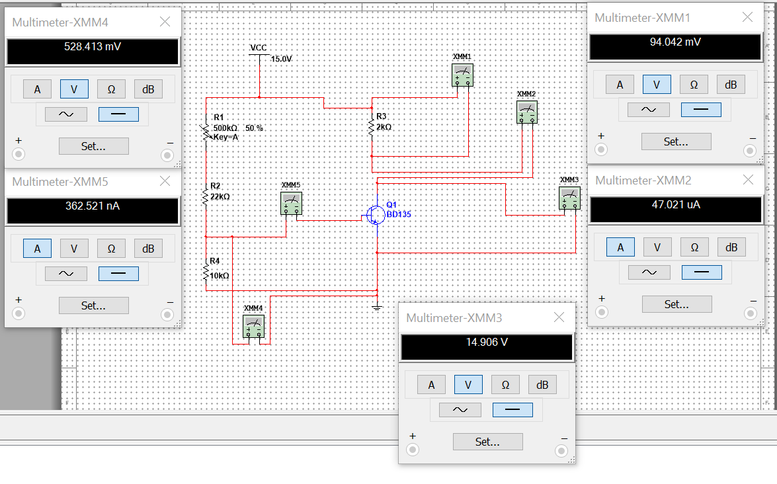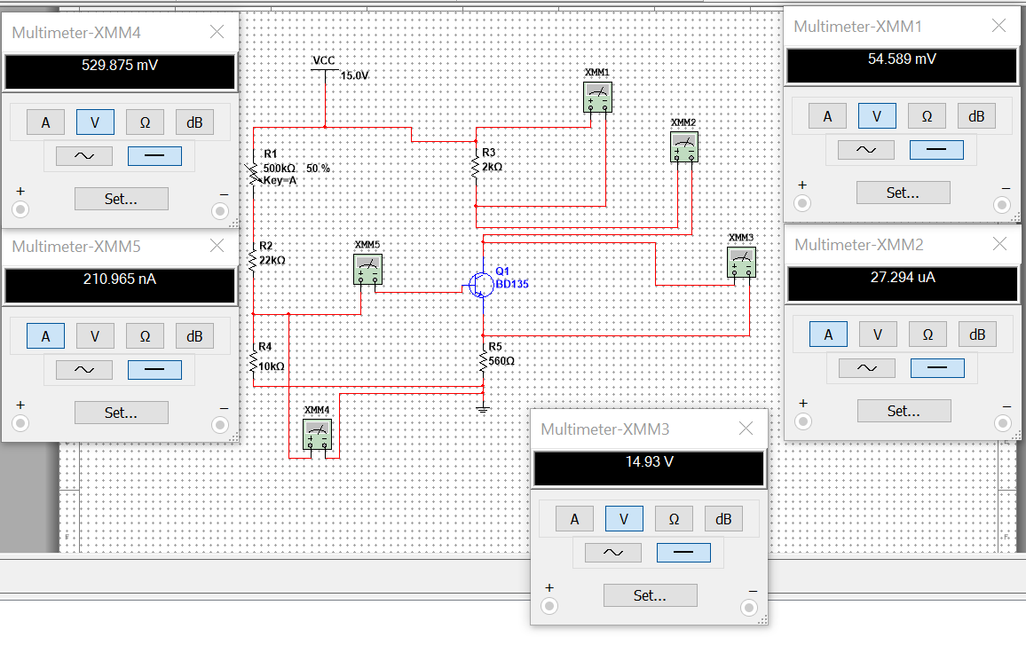

**Data Table:**

|  |  |  |  |  |  |  |
| --- | --- | --- | --- | --- | --- | --- |
|  | **β** | **VCE** | **VBE** | **VRC** | **IC** | **IB** |
| **Fig. 1 (a)** | 124 | 2.007 | 0.657 | 12.99 | 6.496 | 0.052 |
| 200 | 0.12 | 0.661 | 14.88 | 7.444 | 0.053 |
| **% of Change.** | 61.29% | 0.94% | 0.61% | 14.55% | 14.53% | 1.92% |
| **Fig. 2 (a)** | 124 | 1.733 | 3.572 | 10.34 | 5.173 | 0.042 |
| 200 | 0.12 | 3.93 | 11.61 | 5.18 | 0.043 |
| **% of Change.** | 61.29% | 0.93% | 10.02% | 12.28% | 0.14% | 2.38% |
| **Fig. 1 (b)** | 124 | 14.90 | 0.362 | 0.094 | 0.047 | 0.0003 |
| 200 | 14.91 | 0.363 | 0.095 | 0.048 | 0.00023 |
| **% of Change.** | 61.29% | 0.067% | 0.27% | 1.06% | 2.13% | 23.33% |
| **Fig. 2 (b)** | 124 | 14.93 | 0.530 | 0.055 | 0.027 | 0.00027 |
| 200 | 14.94 | 0.531 | 0.056 | 0.028 | 0.00013 |
| **% of Change.** | 61.29% | 0.067% | 0.19% | 1.81% | 3.70% | 38.10% |

**Calculation:**

We know, Ic= VRC/RC

IC= ßIB OR, IB= Ic/ß

Fig 1(a): For, ß =323

Ic=VRC/RC=7.46/466-0.01600 A=16.00 mA

IC= ßIB OR, IB= IC /ß = 16.00/323 -0.04953 mA=49.53 μA

For, ß =327

Ic=VRC/RC=7.71/466=0.01654 A=16.54 mA

IC= ßIB OR, IB= IC /ß = 16.54/337 = 0.04908 mA=49.08 μA

**% 0f change:**

Ic= (16.54-16.00/16.54) *100= 3.26%

IB= (49.53-49.08/49.53) *100= 0.90% (μA)

**Questions for report writing:**

* 1. Why biasing is necessary?

Ans- Biasing improves the output circuit's stability for a range of different values of ß

* 1. Compare the circuits of Fig. 1(a) and 1(b) with respect to stability against variation in β.

Ans: As shown in the preceding table, the percent change in the labeled values is less for 1(b) than for 1. (a). As a result, the stability of circuit 1(b) is greater than one (a). VCE increases as increases, while VBE and VRC decrease.

* 1. Compare the circuits of Fig. 2(a) and 2(b) with respect to stability against variation in β.

Ans: As shown in the table above, the percent change for the values lower, with 2(b) being more stable than 2(a), and an increase in causes an increase in VCE, while VBE and VRC decrease similarly to 1(a) and 1(b) (b). From the table above it is clear that the % change for the values are less with 2(b) being more stable than 2(a) and rise in B causes increase in Vc, while Vas and Vac decreases same as 1(a) and 1(b)

* 1. Compare the stability of fixed bias circuits with that of self-bias circuits.

Ans: Self-biased circuits are more stable than fixed-biased circuits, as the percent differences in values are less for 2(a) and 2(b) than for 1(a) and 1(b) (b). This is because an emitter resistor is present

* 1. What do you mean by stability and Q-point?

Ans: Self-biased circuits are more stable than fixed-biased circuits, as the percent differences in values are less for 2(a) and 2(b) than for 1(a) and 1(b) (b). This is because an emitter resistor is present

**Discussion and Conclusion:**

1. Prior to the experiment's start, all apparatus was inspected. Precautions should be taken to avoid making brief connections. Short connections can generate heat (as a result of the high current flow), which can be detrimental to the components and cause them to fail.

2. The experimental results differed slightly from the simulated results, which could be a result of improper connection, contact resistance, or source power variation.

3. Self-biased circuits are more stable than fixed-biased circuits, based on the data.

**References:**

**1.American International University–Bangladesh (AIUB) Electronic Devices Lab Manual.**

**2.A.S. Sedra, K.C. Smith, Microelectronic Circuits, Oxford University Press (1998) [3] J. Keown, ORCAD PSpice and Circuit Analysis, Prentice Hall Press (2001)**

**3.P. Horowitz, W. Hill, The Art of Electronics, Cambridge University Press (1989).**